CO1- ASSESSMENT TOOL 2
CONCEPT MAPPING

NAME : SHAIK SHOUIB AKTHAR
REG NO : 192312208

QUESTION 1:
Create a concept map linking the following: Security Attacks, Threats, Risks and Security Goals
(Confidentiality, Integrity, Availability. Perform the following tasks:
a. Show how each attack leads to specific threats and risks
b. Map how security goals help mitigate them Provide one real-world example for each link.
ANSWER:
Introduction:
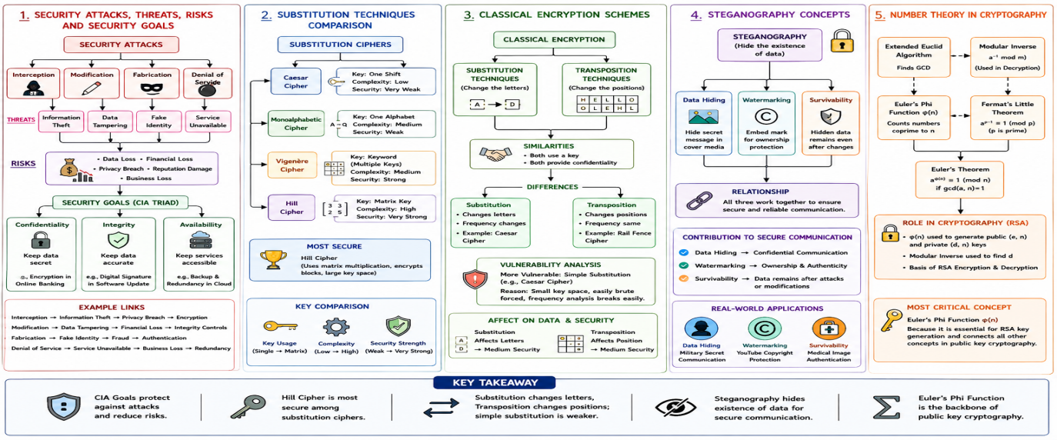
Information security protects valuable data and computer systems from unauthorized access, misuse, modification, and destruction. Cyber attackers continuously attempt to exploit system vulnerabilities through various security attacks. These attacks create threats, which may result in organizational risks such as financial loss, privacy breaches, and service interruptions. To minimize these risks, organizations implement the three fundamental security goals known as the CIA Triad: Confidentiality, Integrity, and Availability.

Security Attacks:
A security attack is any action intended to compromise the confidentiality, integrity, or availability of information.
Types of Security Attacks
1. Interception
- Attackers gain unauthorized access to confidential information.
- Usually performed through packet sniffing, password theft, or spyware.
Threat: Unauthorized access
Risk: Data leakage and privacy violation
Example: A hacker captures login credentials over public Wi-Fi.
2. Modification
- Attackers alter or manipulate stored or transmitted data.
Threat: Data tampering
Risk: Incorrect information and financial loss
Example: An attacker changes transaction details in an online banking system.
3. Fabrication
- Attackers create fake data, fake users, or forged messages.
Threat: Identity spoofing
Risk: Fraud and unauthorized transactions
Example: Sending phishing emails pretending to be a bank.
4. Interruption
- Attackers prevent users from accessing systems or services.
Threat: Service disruption
Risk: Business downtime and customer dissatisfaction
Example: Distributed Denial of Service (DDoS) attack.
Threats
Threats are potential dangers resulting from security attacks.
Examples include:
- Unauthorized access
- Malware infection
- Data manipulation
- Identity theft
- Network intrusion
- Information disclosure
Risks
Security threats create risks that affect organizations.
Common risks include:
- Financial loss
- Reputation damage
- Customer dissatisfaction
- Legal penalties
- Data loss
- Business interruption
- Loss of intellectual property

Concept Map: Security Attacks, Threats, Risks and Security Goals (CIA Triad)
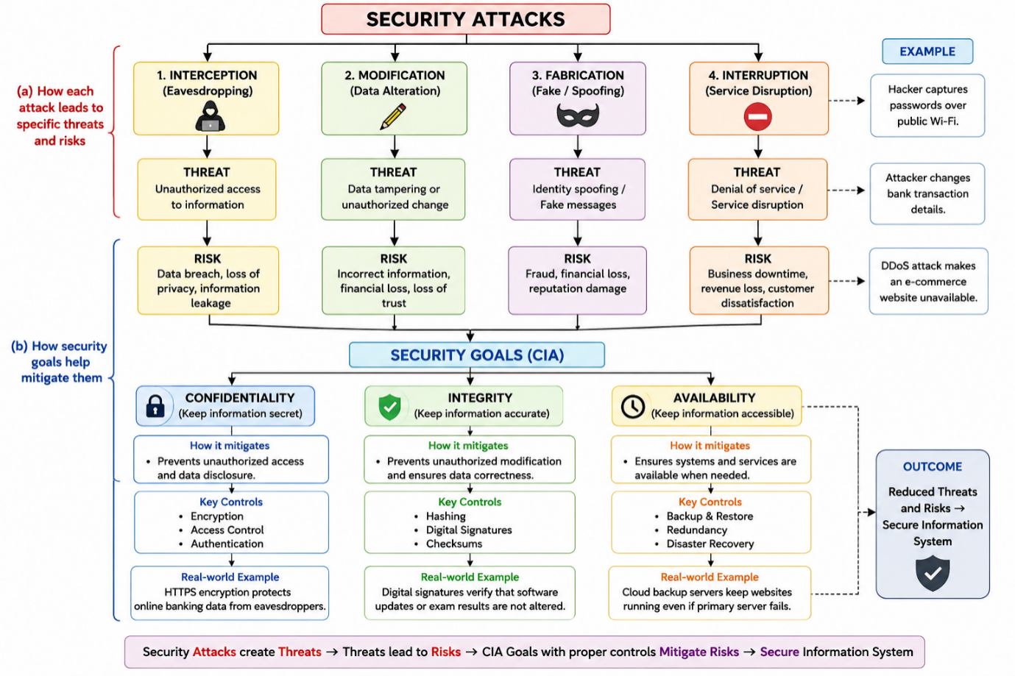
Security Attack | Threat Created | Risk Produced | Real-World Example
Interception | Unauthorized access to confidential information | Privacy breach and data leakage | A hacker captures passwords over public Wi-Fi.
Modification | Data tampering | Incorrect information and financial loss | An attacker changes bank transaction details.
Fabrication | Identity spoofing or fake messages | Fraud and unauthorized transactions | Phishing emails pretending to be a bank.
Interruption | Service disruption | Business downtime and revenue loss | A DDoS attack makes a website unavailable.

QUESTION 2:
Develop a concept map comparing substitution techniques: Caesar Cipher, Monoalphabetic Cipher, Vigenère
Cipher and Hill Cipher. Perform the following tasks to connect based on: Key usage, Complexity and Security
strength. Analyze which technique is most secure and why.
ANSWER:
Introduction:
Substitution techniques are classical encryption methods in which each letter of the plaintext is replaced by another letter, number, or symbol according to a specific rule or key. These techniques protect information by transforming readable plaintext into ciphertext. The four major substitution techniques are Caesar Cipher, Monoalphabetic Cipher, Vigenère Cipher, and Hill Cipher. They differ in terms of key usage, complexity, and security strength.

1. Caesar Cipher
The Caesar Cipher is one of the earliest and simplest encryption techniques. It encrypts data by shifting each letter of the plaintext by a fixed number of positions in the alphabet.
Key Usage
- Uses a single numeric key (k).
- The same key is applied to every character.
Complexity
- Very low complexity.
- Easy to implement and understand.
Security Strength
- Very weak.
- Only 25 possible keys.
- Easily broken using brute-force attacks.
Example
Plain Text: HELLO
Key = 3
Cipher Text: KHOOR
2. Monoalphabetic Cipher
The Monoalphabetic Cipher replaces each plaintext letter with another letter based on a randomly generated substitution alphabet.
Key Usage
- Uses one substitution alphabet.
- The same substitution is used throughout the message.
Complexity
- Moderate complexity.
- More secure than Caesar Cipher.
Security Strength
- Moderate.
- Vulnerable to frequency analysis because each plaintext letter always maps to the same ciphertext letter.
Example
PlainText:
HELLO
SubstitutionAlphabet:
ABCDEFGHIJKLMNOPQRSTUVWXYZ
QWERTYUIOPASDFGHJKLZXCVBNM
CipherText:
ITSSG
3. Vigenère Cipher
The Vigenère Cipher improves the Caesar Cipher by using multiple Caesar shifts based on a keyword.
Key Usage
- Uses a keyword.
- Different letters are encrypted with different shift values.
Complexity
- High complexity.
- Uses multiple substitution alphabets.
Security Strength
- Strong.
- More resistant to frequency analysis than Caesar and Monoalphabetic ciphers.
- Security depends on the length and randomness of the keyword.
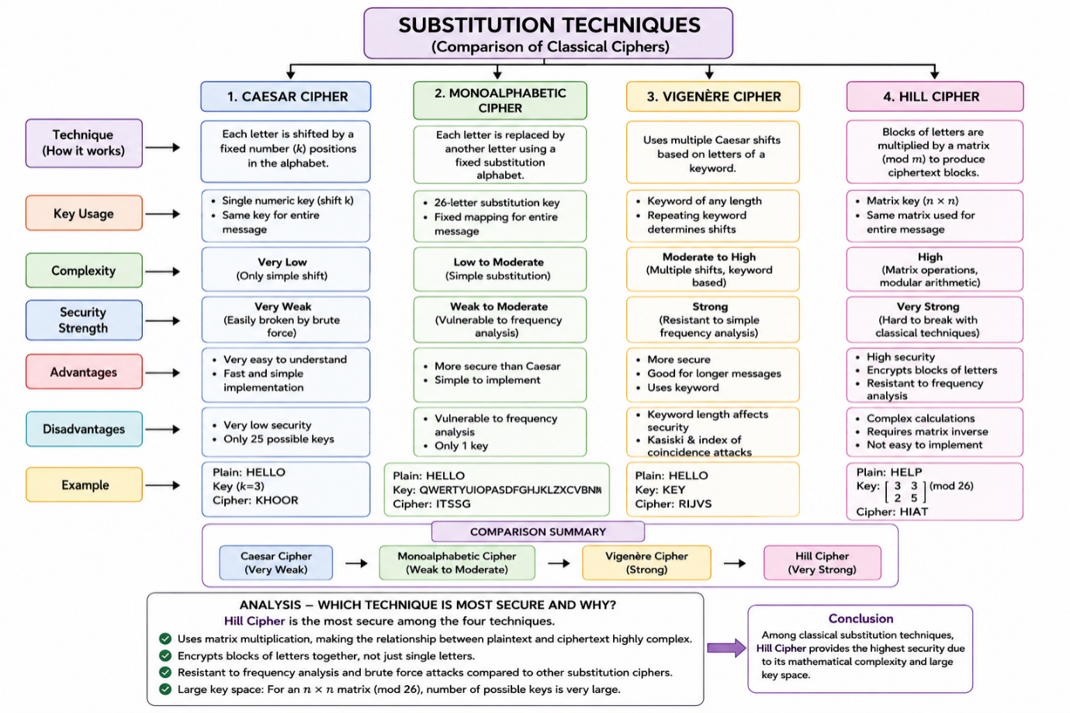

Comparison of Substitution Techniques
Feature | Caesar Cipher | Monoalphabetic Cipher | Vigenère Cipher | Hill Cipher
Key Usage | Single shift key | Random substitution alphabet | Keyword | Matrix key
Complexity | Very Low | Moderate | High | Very High
Security Strength | Weak | Moderate | Strong | Very Strong
Encryption Method | Single letter shift | Fixed substitution | Multiple substitutions | Block encryption
Attack Resistance | Easily broken | Vulnerable to frequency analysis | More resistant | Most resistant among classical ciphers

QUESTION 3:
Construct a concept map for Classical Encryption Schemes: Substitution Techniques and
Transposition Techniques. Perform the following tasks:
a. Show differences and similarities
i. Map how each affects the Data structure and Security level
ii. Analyze which is more vulnerable to attacks and why.
ANSWER:
Introduction:
Classical encryption schemes are the earliest methods used to secure information by converting plaintext into ciphertext. They are mainly classified into Substitution Techniques and Transposition Techniques. Although both methods aim to protect data using encryption keys, they differ in the way they transform plaintext. Substitution techniques replace characters with other characters, whereas transposition techniques rearrange the positions of characters without changing them.
Classical Encryption Schemes
Classical encryption converts readable plaintext into ciphertext using an encryption algorithm and a key. The two major categories are:
- Substitution Techniques
- Transposition Techniques
Both techniques provide confidentiality but use different approaches for encryption.
1. Substitution Techniques
Substitution techniques replace each character in the plaintext with another character, symbol, or number according to a predefined key.
Characteristics
- Replaces letters without changing their positions.
- Uses substitution rules or mathematical transformations.
- Changes the original character values.
Examples
- Caesar Cipher
- Monoalphabetic Cipher
- Vigenère Cipher
- Hill Cipher
Effect on Data Structure
- Character values are changed.
- Character positions remain the same.
Example
Plaintext: HELLO
Ciphertext (Caesar): KHOOR
The letters change, but their positions remain unchanged.
Security Level
- Moderate to High
- Depends on the algorithm and key complexity.
2. Transposition Techniques
Transposition techniques encrypt data by rearranging the positions of characters without changing the characters themselves.
Characteristics
- Characters remain the same.
- Only the order of characters changes.
- Uses permutation or rearrangement methods.
Examples
- Rail Fence Cipher
- Columnar Transposition Cipher
- Route Cipher
Effect on Data Structure
- Character values remain unchanged.
- Character positions are rearranged.
Example
Plaintext:
HELLO
Ciphertext:
LEHOL
The letters remain the same but appear in a different order.
Security Level
- Low to Moderate
- Easier to break using statistical methods.
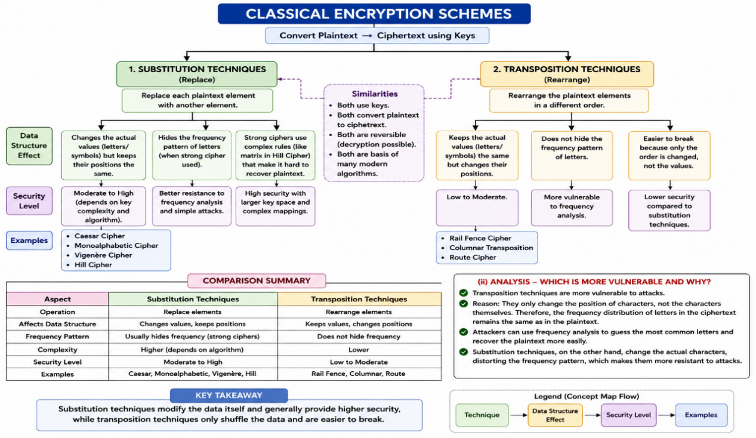
(i) Effect on Data Structure and Security Level
Substitution Techniques
Data Structure
- Changes the actual data values.
- Produces different ciphertext symbols.
Security Level
- Higher because attackers cannot directly recognize the original letters.
- Strong techniques like the Hill Cipher also reduce frequency patterns.
Transposition Techniques
Data Structure
- Original letters remain unchanged.
- Only their positions are rearranged.
Security Level
- Lower because the frequency distribution of letters remains the same.
- Easier to analyze using statistical techniques.
(ii) Analysis: Which Technique is More Vulnerable and Why?
Among the two classical encryption methods, Transposition Techniques are more vulnerable to attacks.
Reasons
- They only rearrange the positions of characters.
- The original letters remain unchanged.
- Letter frequency is preserved.
- Attackers can use frequency analysis to identify common letters and reconstruct the plaintext.
- The key space is generally smaller than that of advanced substitution techniques.
On the other hand, Substitution Techniques modify the actual character values, making frequency analysis more difficult. Techniques such as the Vigenère Cipher and Hill Cipher further improve security by using multiple substitution alphabets or matrix-based encryption.

QUESTION 4:
Create a concept map connecting Steganography concepts: Data Hiding, Watermarking and
Survivability. Perform the following tasks:
a. Show relationships between these concepts
b. Analyze how each contributes to secure communication
c. Include one real-world application for each
ANSWER:
Introduction:
Steganography is the art and science of hiding secret information within a cover medium such as an image, audio, video, or text so that the existence of the message is concealed. Unlike cryptography, which encrypts the content of a message, steganography hides the presence of the message itself. The three important concepts in steganography are Data Hiding, Watermarking, and Survivability. Together, these concepts provide confidentiality, authenticity, and robustness for secure communication.
Steganography
Steganography is a technique used to embed secret information into digital media without noticeably altering the original file. The receiver can extract the hidden information using the appropriate decoding method.
The three major concepts are:
- Data Hiding
- Watermarking
- Survivability
These concepts are interrelated and collectively enhance the security and reliability of digital communication.
1. Data Hiding
Data hiding is the process of embedding secret information into a cover medium so that unauthorized users cannot detect its existence.
Purpose
- Conceals confidential information.
- Prevents attackers from knowing that a secret message exists.
- Protects communication from interception.
Contribution to Secure Communication
- Maintains confidentiality of sensitive data.
- Provides covert communication.
- Reduces the possibility of unauthorized access.
Real-World Application
Military Communication
Military organizations hide confidential messages inside digital images or audio files to securely transmit information without revealing the presence of secret data.
2. Watermarking
Watermarking is the process of embedding ownership or authentication information into digital content.
Purpose
- Protects intellectual property.
- Verifies ownership.
- Detects unauthorized copying or modification.
Contribution to Secure Communication
- Ensures authenticity of digital content.
- Prevents copyright infringement.
- Supports content verification and tracking.
Real-World Application
Copyright Protection
Photographers and media companies embed invisible watermarks in images and videos to prove ownership and prevent illegal distribution.
3. Survivability
Survivability refers to the ability of hidden data or watermarks to remain intact even after the cover medium undergoes modifications such as compression, resizing, filtering, or noise.
Purpose
- Maintains hidden information despite attacks.
- Improves robustness of the steganographic system.
- Ensures reliable communication.
Contribution to Secure Communication
- Preserves hidden information after processing.
- Increases reliability of secure communication.
- Protects embedded information from accidental loss.
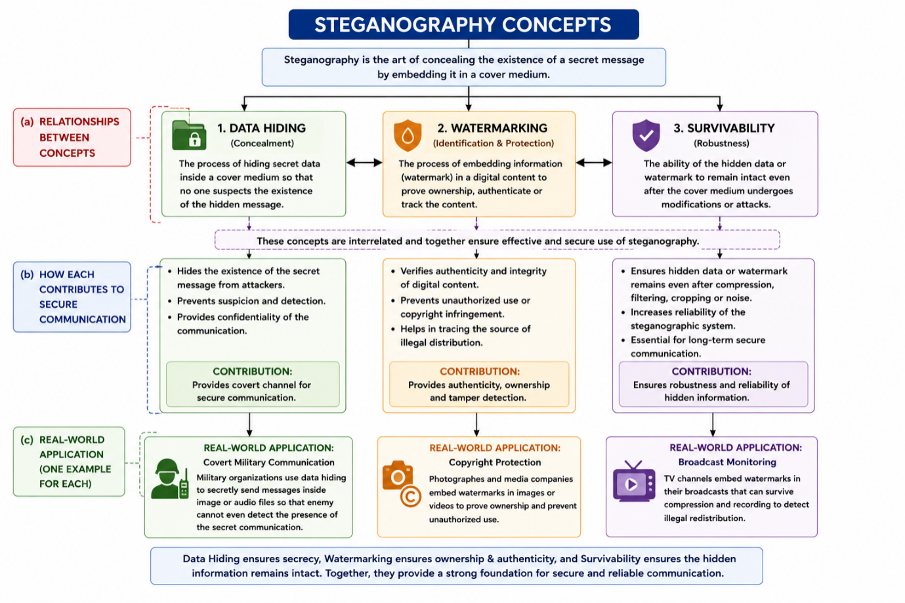
(a) Relationship Between the Concepts
The three concepts work together to provide complete security in steganography.
Concept | Relationship
Data Hiding | Conceals secret information inside a cover medium.
Watermarking | Embeds ownership and authentication information into digital content.
Survivability | Ensures that the hidden data or watermark remains intact after processing or attacks.
Relationship Flow
Steganography
│
▼
Data Hiding
│
▼
Watermarking
│
▼
Survivability
│
▼
Secure and Reliable Communication
(b) How Each Contributes to Secure Communication
Concept | Contribution
Data Hiding | Keeps confidential information hidden from unauthorized users.
Watermarking | Protects ownership, authenticity, and integrity of digital content.
Survivability | Ensures hidden information remains available even after compression, filtering, or transmission.
Together, these techniques provide:
- Confidentiality by hiding the message.
- Authenticity by verifying ownership.
- Robustness by preserving hidden data under various conditions.
(c) Real-World Applications
Concept | Application | Example
Data Hiding | Secure communication | Secret military messages hidden inside images.
Watermarking | Copyright protection | Invisible watermark embedded in digital photographs and videos.
Survivability | Broadcast monitoring | TV channels use robust watermarks that survive compression and recording.

QUESTION 5:
Draw a concept map linking number theory concepts used in cryptography: Modular Inverse, Extended Euclid
Algorithm, Fermat’s Little Theorem, Euler’s Phi Function and Euler’s Theorem. Perform the following tasks:
a. Show how each concept is mathematically connected
b. Map their role in encryption/decryption
ANSWER:
Introduction
Number theory is the mathematical foundation of modern cryptography. Many public-key encryption algorithms, such as RSA, depend on concepts like the Extended Euclidean Algorithm, Modular Inverse, Euler's Phi Function, Fermat's Little Theorem, and Euler's Theorem. These concepts work together to generate cryptographic keys, perform encryption and decryption, and ensure secure communication over untrusted networks.
1. Extended Euclidean Algorithm
The Extended Euclidean Algorithm is an extension of Euclid's algorithm that computes the Greatest Common Divisor (GCD) of two integers and also finds the modular inverse of a number.
Role
- Computes GCD.
- Finds Modular Inverse.
- Used during RSA key generation.
Example
Find the modular inverse of 7 mod 26.
2. Modular Inverse
A modular inverse is a number that satisfies
$$a×b≡1(modn)$$
It is essential for calculating the private key in RSA encryption.
Role
- Generates RSA private key.
- Used during decryption.
Importance
Without a modular inverse, RSA private keys cannot be generated.
3. Euler's Phi Function (φ(n))
Euler's Phi Function calculates the number of positive integers less than n that are relatively prime to n.
Example
φ(10)=4
because 1,3,7,9 are relatively prime to 10.
Role
- Computes RSA keys.
- Determines the private exponent.
- Used together with Euler's Theorem.
4. Fermat's Little Theorem
For any prime number p,
$$a^{p−1}≡1(modp)$$
Role
- Performs modular arithmetic.
- Used in primality testing.
- Forms the basis of Euler's Theorem.
5. Euler's Theorem
Euler's Theorem generalizes Fermat's Little Theorem.
If
gcd(a,n)=1
then
$$a^{ϕ(n)}≡1(modn)$$
Role
- Mathematical foundation of RSA.
- Ensures correct encryption and decryption.
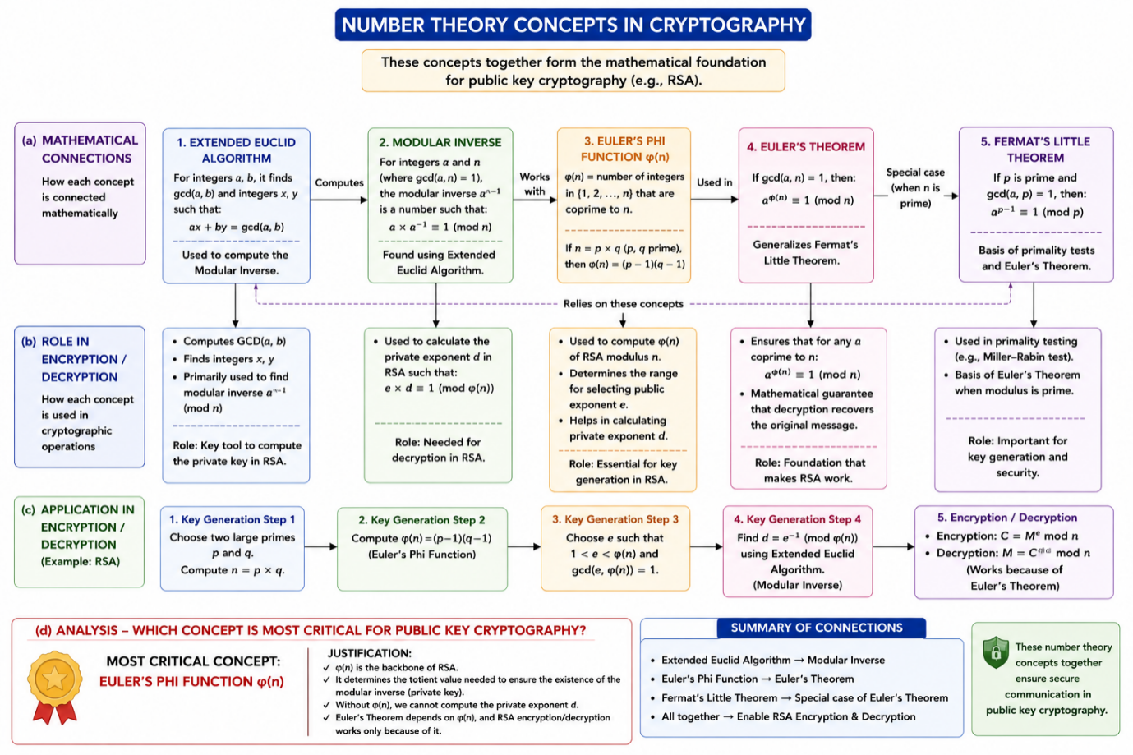

(c) Analysis: Most Critical Concept for Public-Key Cryptography
Among all the number theory concepts, Euler's Phi Function (φ(n)) is considered the most critical for public-key cryptography, particularly in the RSA algorithm.
Justification
- It is used to generate both the public key and the private key.
- It determines the value required to compute the modular inverse, which forms the private exponent.
- Euler's Theorem depends directly on φ(n), making it essential for the correctness of RSA encryption and decryption.
- Without φ(n), RSA key generation cannot be completed.
Although the Extended Euclidean Algorithm computes the modular inverse and Euler's Theorem proves the correctness of RSA, neither can function effectively without the value of Euler's Phi Function. Therefore, Euler's Phi Function is the backbone of RSA-based public-key cryptography.

